Write a program to find greatest among 3 numbers.

#include<stdio.h>

main()

{

int a,b,c,max=0;

scanf("%d",&a);

scanf("%d",&b);

scanf("%d",&c);

if(a>b && a>c)

{

printf("%d",a);

}

else

{

if(b>a && b>c)

{

printf("%d",b);

}

else

{

if(c>a && c>b)

{

printf("%d",c);

}

}

}

}

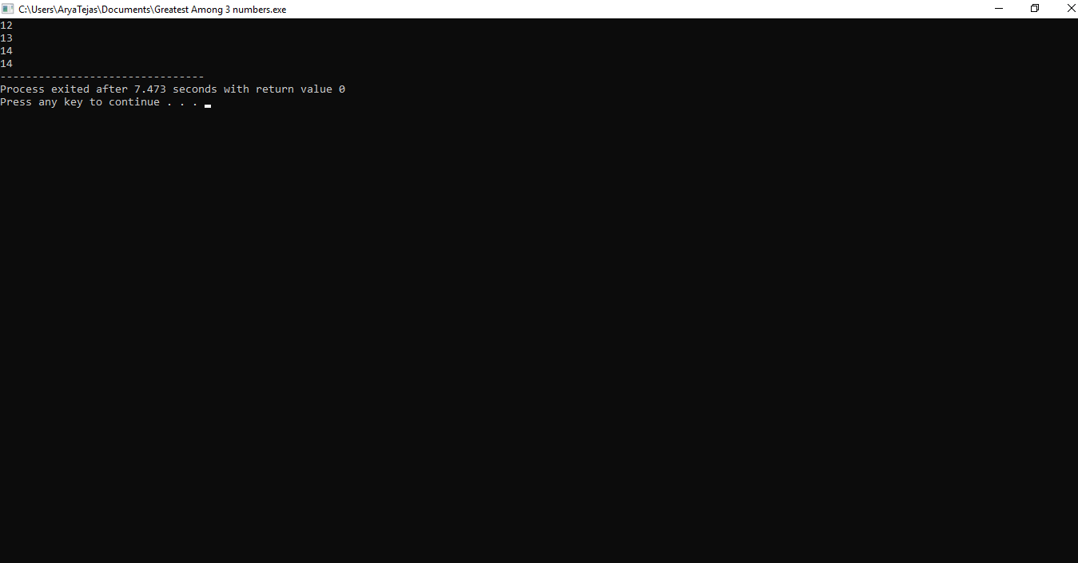

2.Find number of digits and display each digit of given integer value.

#include<stdio.h>

main()

{

int n,x,count=0,d;

scanf("%d",&n);

x=n;

while(x!=0)

{

d=x%10;

printf("%d \n",d);

count++;

x=x/10;

}

printf("Number of digits=%d",count);

}

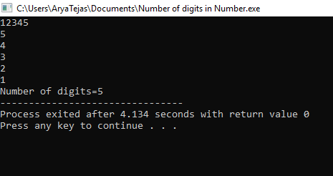

3.Write a program to enter marks at 6 different subjects and find total marks and average.

#include<stdio.h>

main()

{

int i,m,sum=0;

for(i=1;i<=6;i++)

{

scanf("%d",&m);

sum=sum+m;

}

printf("Total Marks=%d\n",sum);

double avg=sum/6;

printf("Average Marks=%lf",avg);

}

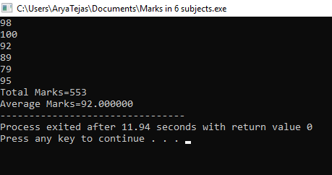

4.Find smallest and greatest among the given set of numbers.

#include<stdio.h>

main()

{

int i,m,max=0,min,n;

scanf("%d",&n);

for(i=1;i<=n;i++)

{

scanf("%d",&m);

if(i==1)

{

min=m;

continue;

}

if(m>max)

{

max=m;

}

else

{

if(m<min)

{

min=m;

}

}

}

printf("Greatest Number=%d\n",max);

printf("Smallest Number=%d",min);

}

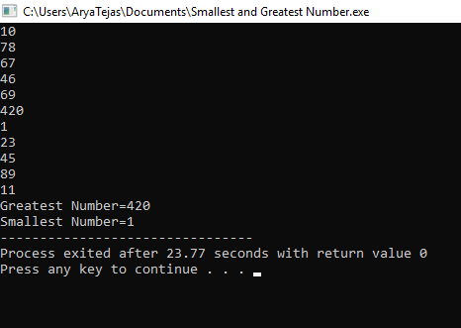

5.Sorting of given set of Numbers.

#include<stdio.h>

main()

{

int n,i,j,m,temp;

printf("Enter number of numbers to be sorted:");

scanf("%d",&n);

int a[n];

for(i=0;i<n;i++)

{

scanf("%d",&m);

a[i]=m;

}

for (i = 0; i < n-1; i++)

for (j = 0; j < n-i-1; j++)

if (a[j] > a[j+1])

{

temp=a[j];

a[j]=a[j+1];

a[j+1]=temp;

}

for(i=0;i<n;i++)

{

printf("%d ",a[i]);

}

}

